Statistical Modeling Assignment #1
POLS 310W
Erin O’Reilly
September 12, 2019

The United States is a proud country. Proud of its cities, celebrities, mountains and monuments; but also, of its loyalty to democracy. For centuries the U. S. has defended the freedom to vote both at home and abroad. The heart of U.S. foreign policy for decades remained to stop the spread of communism and replenish lost democracies in the world. Whilst achieving some success abroad, the U.S. seems to have failed to ensure a strong democratic system at home. Between 1970 and 1972 congressional voter mobilization dropped dramatically. Voter participation is vital in ensuring a healthy democracy, and such drops call into question the state of the United States’ political system as a whole. This report analyses this trend and looks to social, economic, and political reasons for a decrease in voter participation.
Throughout most of the 1900s, the United States witnessed an overall steady downfall in voter participation. As illustrated by figure 1, the fall began early in the century. Participation began to climb once again following the 19th amendment but fell victim to effects of the Great Depression. and war overseas, in both feasibilities to vote and anger towards the government’s role in these conflicts. This paper focuses on a smaller time period, between 1952 and 1988. Within this time period we see two very different pictures of voter participation. Between on and off presidential election years, a drop is expected in congressional electoral mobilization, and throughout 1952 to 1970 this drop remains somewhat constant. However, there is a stark drop between 1970 and 1972 that continued until 1988. An economic plague, political scandal, and social unrest all contributed to this almost 20 yearlong decline.

Figure 1. A line graph displaying the trend in mean congressional electoral mobilization from the year 1900 to 1988.
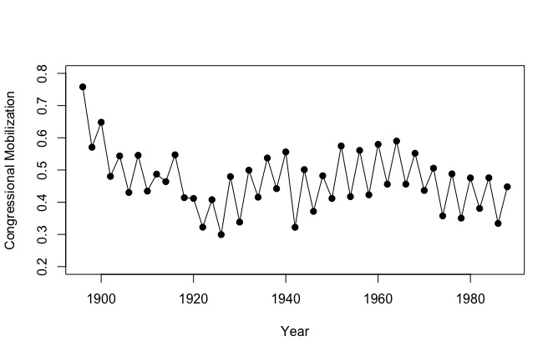
Between 1952 and 1970 the United States enjoyed a healthy participation in democracy. As illustrated in figure 2, the on-year voter congressional electoral mobilization remains almost constant over the 18-year period, dipping just slightly between 1964 and 1968. This makes it all the more intriguing that off-year congressional electoral mobilization actually increases in the last 10 years of the time period. This perhaps can be attributed to the social activism of the decade and increasing education level of the public as a whole.

Figure 2. A line graph displaying trend in mean congressional electoral mobilization from the year 1952 to 1970.
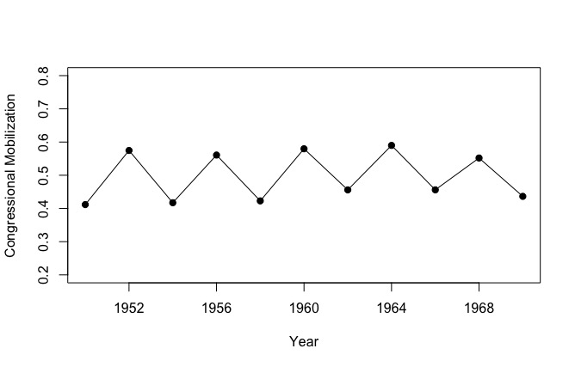
The 1960s were time of great social change in the United States. Activism and a rise in the power of media exaggerated the growing distance between the government and the people, and this distance undoubtedly contributed to the drop in voter participation in the 1970s and 80s. This decrease is illustrated by figure 3 which conveys the consistency in the decrease across the 16 -year period. Whilst the 1960s were a turbulent time plagued with assassinations and change, the government marched forward towards progress in equality and freedoms through the presidencies that ruled the Great Society policies. It is perhaps because of these achievements and loyalty to progress that the turmoil that plagued the 60s did not affect popular trust in the democratic system until the election of Richard Nixon in 1968.
The fight for equality continued into the 1970s but was met by a new stronger right that idolized tradition and conservatism. This fueled a polarized divide in American politics that still remains today. Since the 1960s the US has watched the country’s political parties grow more divided and extreme, and with that the population move further from party identification. Lack of party loyalty depressed motivation to vote, as voters found little to relate to or trust in political candidates.

Figure 3. A line graph displaying trend in mean congressional electoral mobilization from the year 1972 to 1988.
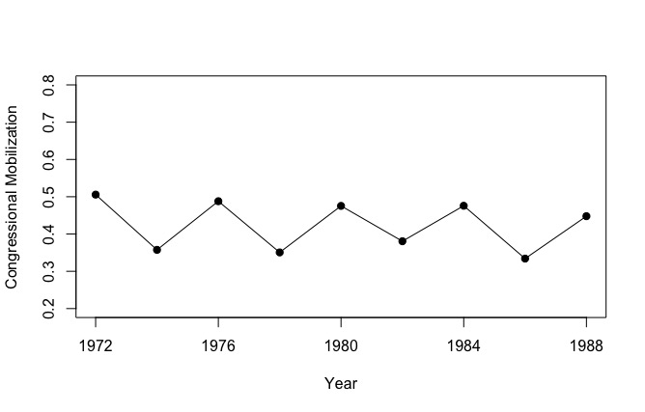
Whilst the long-term societal turmoil and divides are important in this analysis, perhaps the largest contributor to the stark decrease in congressional mobilization between 1970 and 1972 is the political calamity of Richard Nixon, and the mess that followed with his resignation. Watergate provided the public with a chance to look behind the curtain of the government, and the people did not like what they saw. The dishonesty displayed by the commander in chief was deeply troubling for much of the country, and while Nixon still managed to clinch reelection in 1972, just a couple of months after the scandal broke, voter turnout was low, and the scandal plagued his presidency culminating in his resignation in 1974. Although the economic, social and other political contributions to voter turnout throughout the time period should not ignored, the revelation of Watergate and Nixon’s indiscretions seems to be the trigger for the drop in congressional mobilization between 1970 and 1972, originally illustrated in figure 1.
The public response to Watergate set the tone of elections for several years to come. The level of distrust of the government was at such a high that many simply gave up on political involvement. Parties saw a drop in loyalty and participation, and those who remained often held more extreme views, pushing the two sides further and further away from each other. As extremes in parties increase, incentives to join decreased. The lasting impact of the distrust brewed by the Watergate scandal and president Nixon is highlighted in table 1 which compares mean congressional electoral mobilization between 16-year periods on before and after the scandal. It is important to note not only the stark differences between the time periods but also the differences between on and off years. It’s intriguing to note that there is a smaller difference between on and off years in the time period following the water gate scandal, meaning that while fewer vote, a higher proportion of voters are understanding the importance of off year congressional voter participation. It’s difficult to infer what the reason behind this is, perhaps an indication of a more educated public, or perhaps that the population that continued to vote post-Watergate was more invested in politics and thus more likely to vote in both on and off years.

Figure 1. A table displaying the on and off year mean congressional electoral mobilization for two different time periods.
Time Period | ON | OFF
1950 - 1970 | 0.5714173 | 0.433351
1972 - 1988 | 0.4785511 | 0.3556935

Social unrest and political turmoil were met with economic crisis in 1973 that further exaggerated political distrust and unhappiness in the population. Economic growth came to a halt, unemployment and interest rates skyrocketed, and the public’s anger towards the government grew. An emotional and reactive public blamed the government for their lost jobs, and the economy was slow to recover before being hit with a second recession in 1980. This anger towards the government indubitably contributed to the lower mean congressional electoral mobilization between 1972 and 1988.
The United States’ political health in the mid 20th century was fraught with disease. A culmination of economic, social, and political factors triggered a downfall in voter participation that lasted almost two decades. A growing social unrest and divide fueled a growing distrust in the public that climaxed in the revelation of Watergate and triggered the blatant drop in voter participation in 1972. This depression continued for many years after, driven by loss of party loyalty and identity, social divide, economic crisis, and political distrust. Government are about people, and politicians are about the people they serve. A government is only healthy when its people believe it to be. And when voting goes down, so too does the health of a country’s political system. As of 2016, the United States still trails most of the developed world in voter participation, however, has trended upwards since the data analyzed in this report.

